MINUTES
of the
Army Health Services Historical Research Group
Workshop
Held at 0900 to 1200, 12th July 2008
in
Building 32 Conference Room
At
Keswick Barracks

1. Attendees:
COL B Perks (Chair), Col A Summers (Minute secretary), COL D Beard, COL S Cameron, COL M Jelly, GPCAPT C Verco, COL J Aiello, COL P Byrne.

2. Apologies:
COL B Mollison, LTCOL S Kuusk, COL R Beal, LCDR A Swain.

3. Business arising from the previous workshop
The agenda was reviewed and the structure of the meeting was discussed to address various factors.
3.1. COL Perks presented a brief snapshot of our achievements since the inauguration of this committee.

3.2 It was agreed that this group had
- Affiliated with the Army Museum of South Australia (AMOSA)
- Created an identity
- Established some funding
- Created a means of dissemination through the RAAMC Website.
3.3 Further discussion led to the acknowledgement that we maintained an adherence to our stated aims of the last strategy meeting re-iterated here:-

- The Executive would be responsible to consolidate the activities of all groups and for strategic planning of Health history in this State through the Army Museum of South Australia.
- Identify sources of information relating to the Army Health Services in South Australia
- Collect and record army medical/health history through its subgroups
- Collect objects, photographs, diaries, printed matter and letters
- Collate the collected material
- Preserve and conserve the memorabilia as part of the AMOSA collection
- Publish the collected history initially on a web site
- Raise funds specifically to carry out and support this project.

3.4 It was further discussed that we had not achieved the establishment of sub-groups as proposed at the last meeting. It was agreed that we should concentrate on the establishment of a nursing and dental sub-group as a first priority. This led to two points to be raised for further discussion in new business namely:-

- The inclusion of the other rank history in our mandate
- The formulation of terms of reference for this group.

3.5 COL Perks stated that it was important that there was a means to create a database through a website so that Health services members could enter their names and details.

It was not financially or physically viable for this group to do this.

After discussion it was decided that COL Perks would raise this with Major John Straskye to see if he can come up with a solution, as part of the future vision of the existing website.

3.6 COL D Beard was confirmed as Patron with acclamation. COL Perks to write to COL Beard on the new letterhead to confirm.

3.7 COL Perks to seek permission from COL Andersons to use and modify the Regional Letterhead. The committee expressed the desire that the images of Corps badges on the letterhead include RAAMC, RAANC, RAADC, AAPsych.

3.8 Sponsors
There was general discussion about the need for sponsors. There was significant discussion concerning SA family names with long established RAAMC connections.

4. Presentations

4.1.1
COL Perks then invited COL Byrne to speak to the group about the work he has been doing for this group.

COL Byrne reported that he had compiled a comprehensive list of former and current RAAMC – SA Officers. He has obtained some of the information from MAJ Don Chapman. COL Byrne is currently researching and updating this list. COL Byrne also has the information on some WW2 Medical Corps Associations which have now disbanded and will be useful in updating his lists.

4.1.2
COL Byrne then went on to report that he and COL Perks visited John Davies at a nursing home in the Southern suburbs. Mr. Davis has loaned COLs Perks and Byrne a portfolio of 2/8 FD AMB photographs to have photocopied or reproduced. COL Byrne will organise to have significant photos reproduced. In the meantime COL Summers will scan the albums so that we have a record of the photos to be place in the museum for research purposes.

4.1.3
COL Byrne also reported the serendipitous meeting with the lady at the reception desk of the nursing home who has in her possession a small leather suitcase containing many cloth-backed maps from WW1 that belonged to her grandfather. Contents of the suitcase are yet to be catalogued but an initial investigation reveals trench maps of the Somme and early aerial photographs. The owner has agreed to let us have access to them to investigate how they need to be preserved and copied. It was agreed that the War Memorial in Canberra may be very interested in this memorabilia and COL Summers will ask AMOSA if they can advise us on how to proceed.

COL Perks pointed out that all the memorabilia is to be returned to the current owners.

COL Byrne has agreed to interview John Davis with the assistance of GPCAPT Verco.

COL Perks thank him for his input.

4.1.4
COL Perks then invited COL Beard to speak to the group.
COL Beard presented to the workshop a group photo of RAAMC Officers Training Wing 1962.
Much discussion ensued and plans to have a reproduction of the photo were agreed. COL Summers took a photocopy for museum records. This important photograph is reproduced as part of the minutes as a future record.

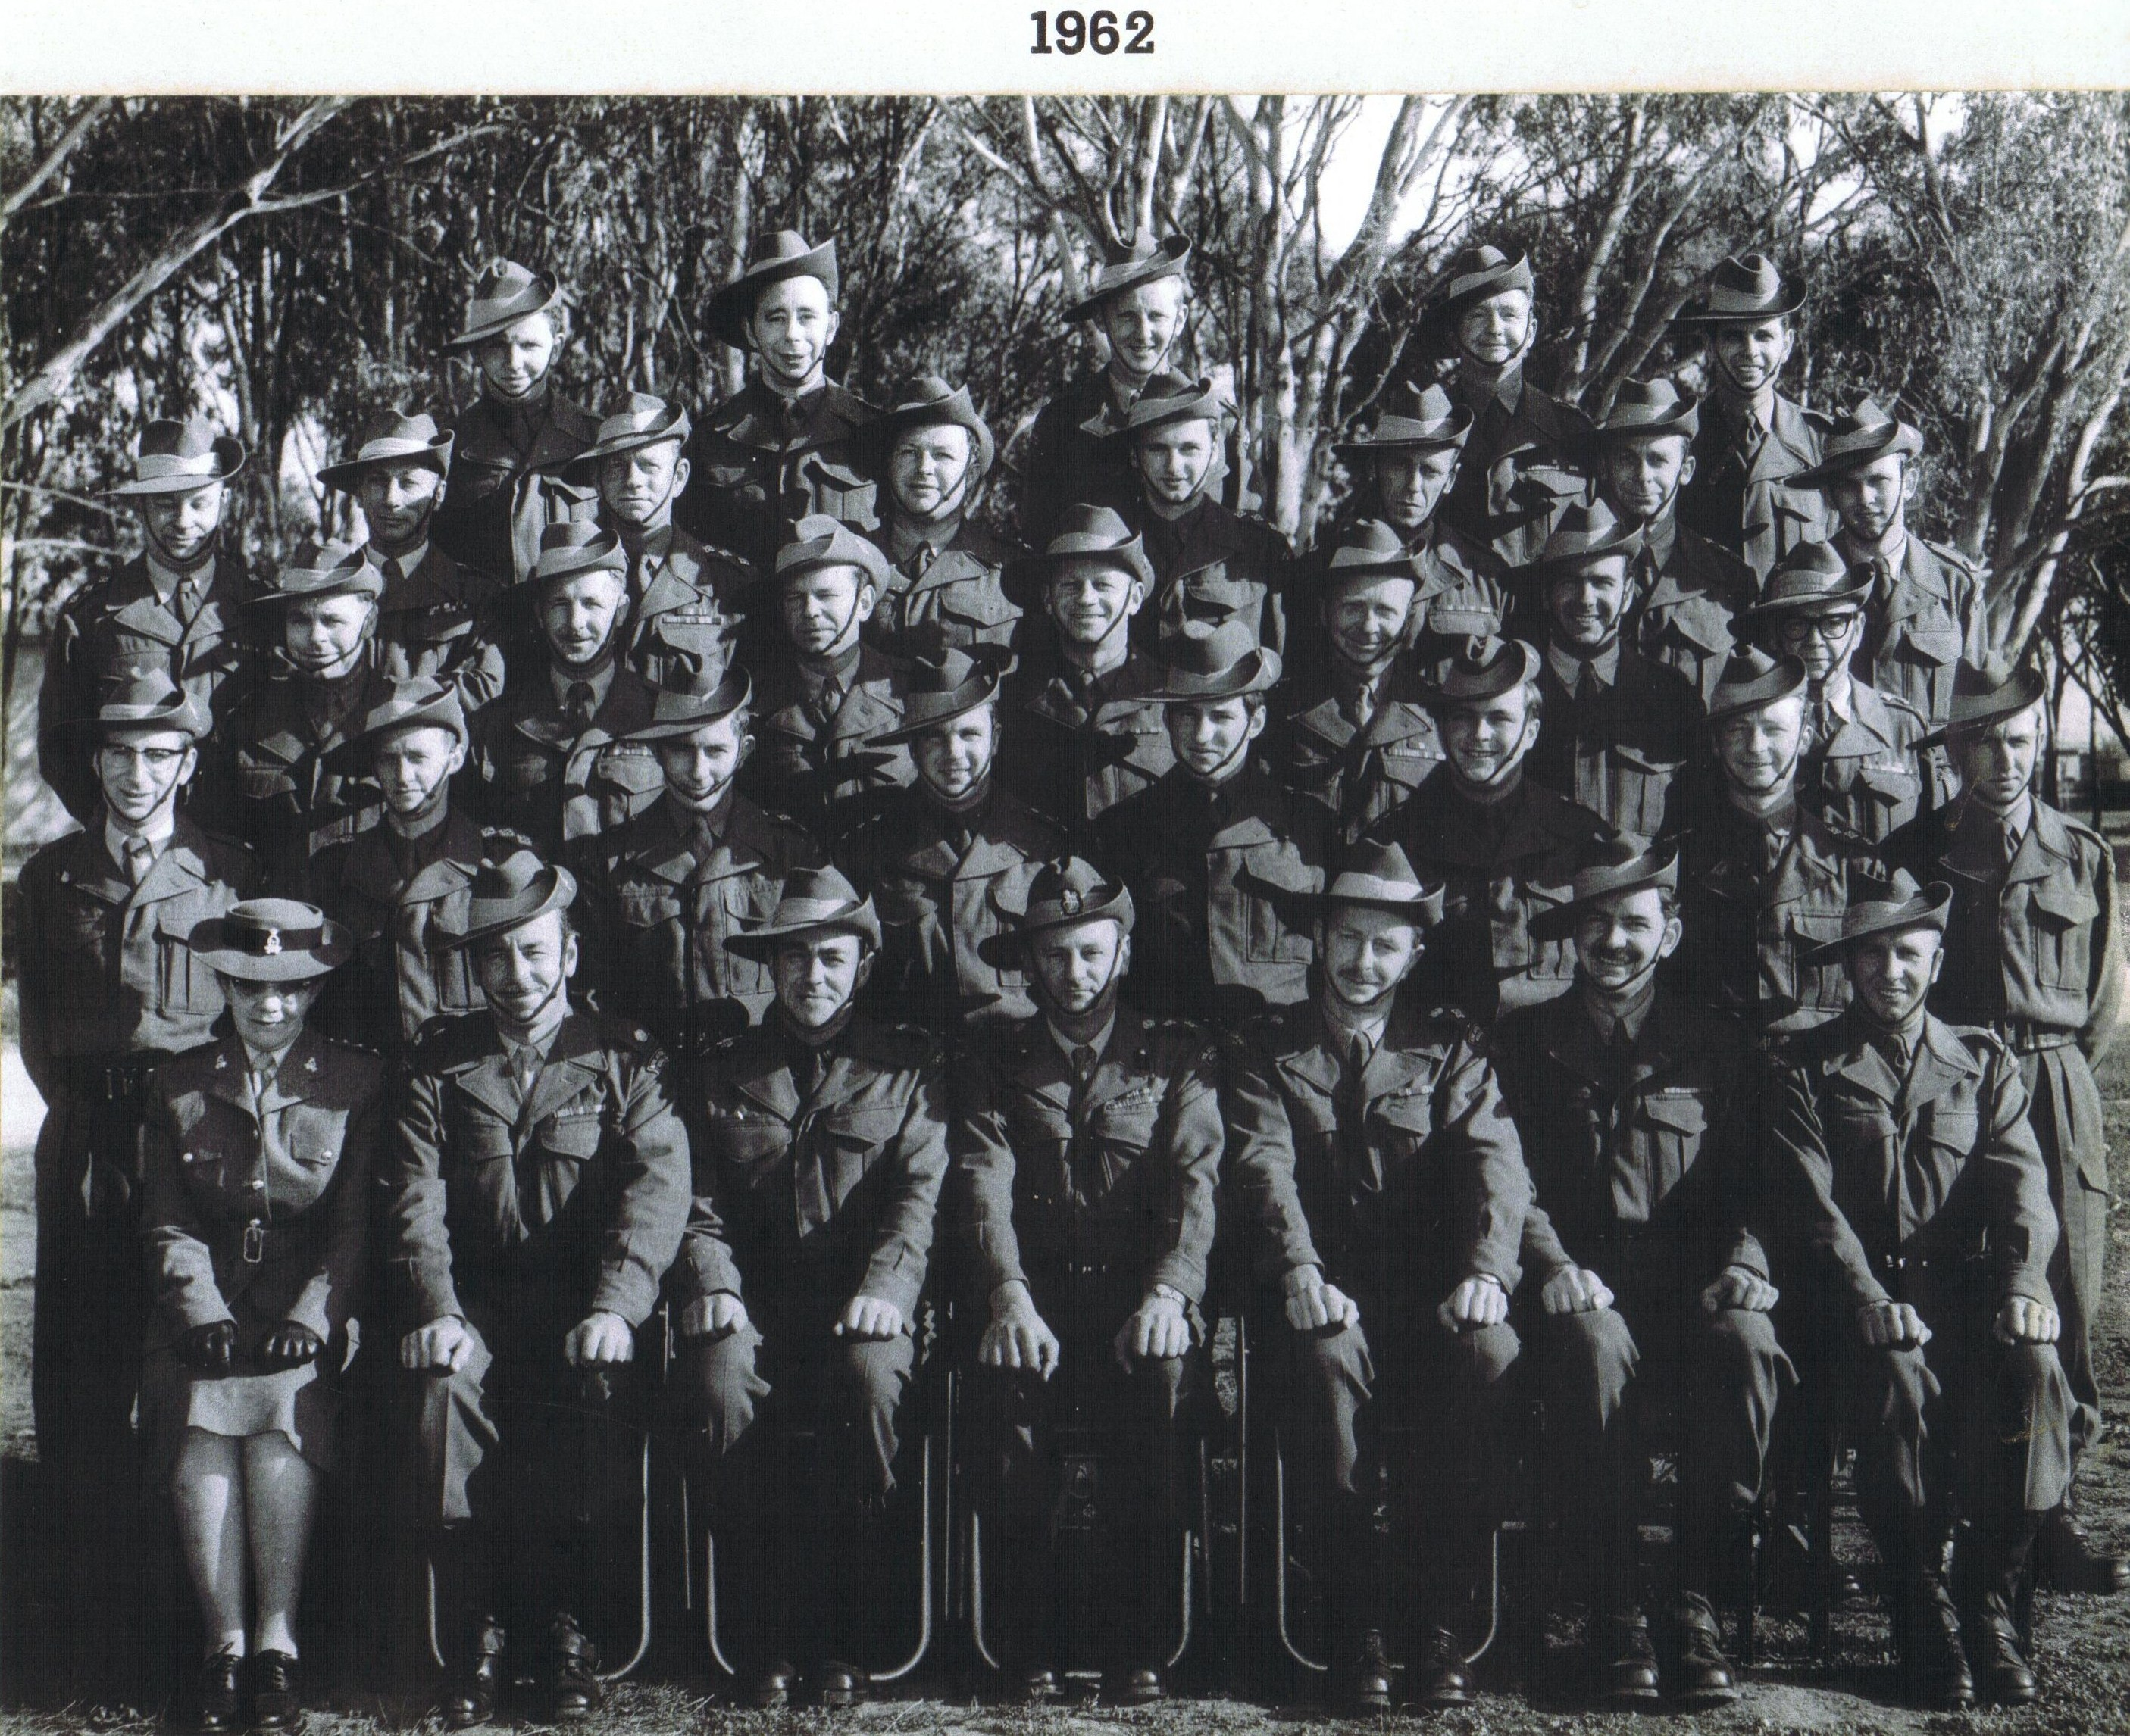

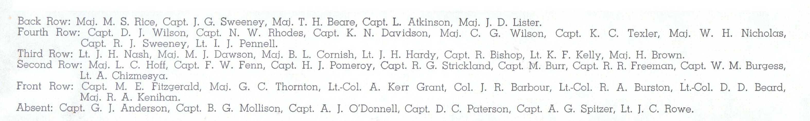

The meeting then paused for morning tea and COL Perks thanked COL Aiello for organizing it. COL Byrne then left the workshop to travel back to Wirrabara.

5. New Business

5.1.1 The inclusion of the other rank history in our mandate.

GPCAPT Verco raised the issue of how the group will preserve and record the history of RAAMC other ranks. To date this group has mainly concentrated on the history of officers. GPCAPT explained that this question occurred to him after a meeting he had with Mr. Brenton Whittle a news reader whose late father, a journalist and conscientious objector, served as a medic with 2/8 Field ambulance at Tobruk. Whittle kept a detailed day by day diary containing a vast amount of detail.
Much discussion ensued as many of the committee had attended a 3rd FD AMB 3rd Gen Hosp re-union the previous day organised by a keen group of previously serving OR’s and the same question arose.
It was agreed that this committee would open up 2 positions on the committee
1. A person who is not in the military but has a connection to military history through family and has a strong interest in preserving that history.
2. A member or former member of the RAAMC who has strong links with the other ranks who is interested in preserving the history of OR’s.
Several names were put forward and it was decided that we would have a small function and invite the nominated people to attend. Selection for these two positions would be made following the function.
5.1.2 The formulation of terms of reference for this group.
COL Aiello suggested to the committee that it was time to form Terms of Reference for the group.
The terms of reference would define:-
- the structure
- how we operate
- how we meet
- key executive positions and elections
- length or terms of office
- How minutes are circulated
The group agreed with this confirming that this would enhance the governance of the group. COL Aiello volunteered to formulate a draft of the Terms of Reference for the group to consider at a future meeting.
5.1.3 Database
The issue of a database was further discussed. It was acknowledged that there are various databases already compiled by different units and organisation for different purposes. The group that organised the aforementioned re-union is creating a database for the purpose of maintaining contact and social reunions. It was suggested that we ask them if we could link into this bearing in mind that the reason for this group to create a data base was for the purpose of maintaining a historical record of serving personnel. COL Jelly to contact Andrew Jelly and Bill McLaughlin to see if this is possible. This may be one way of linking the OR group to our group in preserving our history.

5.1.4 Functions
After discussion it was agreed that we would look at 2 functions
1. A small cocktail party to be organised at the Naval, Military and Air Force Club. Invitees to include all committee members (past and present), people who have assisted us in providing historical records to date and potential new members to the committee as previously discussed in 5.1.1.
Date Tuesday 18th November
Annette to create the invitation
Cost to be shared amongst the committee members
Suggested invitees recorded by COL Perks
COL Perks to book venue
2. It was suggested that we also plan for a larger function in 2009 and seek the assistance of CO 3 HSB and other relevant units. This will be to disseminate what we are doing and to engender an interest in RAAMC history. No further discussion but planning for this function will be progressed through our monthly meetings.

6. Next Meeting
The group confirmed that it would be appropriate to have another workshop in July 2009 to review plans and outcomes.
Workshop closed at 1200.

Signature of Chair................................................

Date..................................................

